NBA Mini World ER Model

Alpha and Beta: Ryan Garner

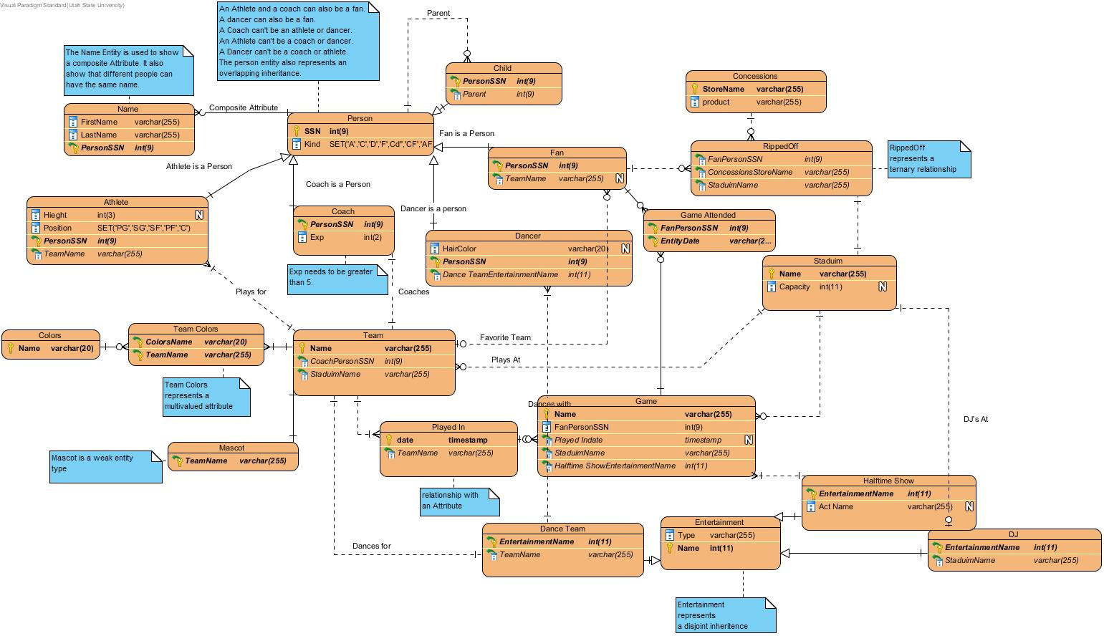

Overview

My ER model of my chosen mini world represents the NBA, National Basketball Association. There are three main entity types in my model, a person, a team, and the entertainment. I chose to make the model using Visual Paradigm. I felt that it would provide the best way to represent each deliverable. There were some deliverables I felt might be unclear as to what they were to represent so I left notes to describe what I was trying to accomplish. I wasn’t sure how to represent inheritance visual paradigm offered a subtype relationship type so I assumed that would be an appropriate representation.

Entity Types

Person:

Definition: Super class for several different types of people. Superclass for overlapping inheritance.

Attributes: PrimaryKey-SSN, A SSN is unique to each individual person whereas a name is not, Kind has a domain constraint can only be one of A,C,F,D,Cd,CF,AF, Composite Attribute Name.

Athlete:

Definition: Subclass of person. An athlete can also be a fan.

Attributes: Height and Position has domain constraint can only be one of PG SG SF PF C

Coach:

Definition: Subclass of person. A coach can also be a fan.

Attributes: Exp, Exp has a Check Constraint a NBA coach needs at least 5 years of experience.

Dancer:

Definition: Subclass of person.

Attributes: HairColor

Child:

Definition: Subclass of person.

Attributes: no unique attributes

Team:

Definition: A collection of athletes and one coach. They face off in games against other teams.

Attributes: Primary-Key Name, there can only be one team of each name in the league. Team Colors, this is a multivalued attribute.

Game:

Definition: A match between two different teams.

Attributes Primary-Key Name, the name is unique to each game it is in the format of Team1vsTeam2.

Mascot:

Definition: Weak Entity type. Dependent on team.

Attributes: Primary-Key is the team name.

Stadium:

Definition: location where games take place

Attributes: Primary Key, name, each stadium has a unique name. Capacity.

Concession:

Definition: Stores in stadium.

Attributes: Primary Key, store name each concession will have a unique store name. Product.

Entertainment:

Definition: Super class for several different forms of entertainment. Superclass for a disjoint inheritance hierarchy.

Attributes: Primary key Name, Each form of entertainment will have a unique group/individual name. Type.

Dance team:

Definition: Subclass of Entertainment. Collection of dancers.

Attributes: TeamName.

Halftime Show:

Definition: Subclass of Entertainment. Show for halftime of games.

Attributes: Act Name.

DJ:

Definition: Subclass of Entertainment. Plays music for a specific stadium.

Attributes: no unique attributes.

Relationship Types

Plays For:

One to many relationship between Athlete and Team. Each Athlete has one team and each team has many athletes.

Coaches:

One to one relationship between Coach and Team. Each Team has one Coach. Each Coach coaches one team

Parent:

One to zero or many relationship between person and child. Child has one parent and a parent has zero to many children.

Favorite Team:

Zero to Many to zero to One relationship between Fan and team. A team can have zero to many fans. A Fan only has zero to one favorite team.

RippedOff:

A ternary relationship between fan many, concession many, and stadium one. Fans can buy multiple concessions from one stadium.

Plays at.

A one to zero to many relationship between team and stadium. A stadium has zero to many teams. A team plays at zero to one stadium.

Dances with:

A one to many relationship between dancers and dance team. Each dancers have one dance team. Each dance team has many dancers.

Played in.

A many to many relationship between team and game. A game has many teams and a team can play in multiple games. This relationship has a date Attribute.

Dances for:

A one to one relationship between a dance team and a team. A dance team dances for one team. A team has one dance team.

Performed at:

A one to many relationship between a game and a halftime Show. Each game has one halftime show. Each halftime show can play multiple games.

DJ’s at:

A one to one relationship between DJ and stadium. Each DJ DJ’s at one stadium. Each stadium has one DJ.

Game Attended:

A many to many relationship between Game and Fan. A Fan can attend many games. A game can have many fans.

Alpha and Beta Contribtions were done by Ryan Ganer.

Alpha

* A many-one relationship type with total participation on the one side – Satisfied by the Plays at relationship.
* A many-many relationship type – Satisfied by the Game Attended relationship.
* A ternary relationship – Satisfied by the rippedOff relationship.
* A disjoint inheritance hierarchy – Satisfied by the Entertainment entity and its subclasses.
* A composite attribute – Satisfied by the Name attribute in person.
* A domain constraint – Satisfied by the Kind attribute in person and position attribute in athlete.
* A multivalued attribute – Satisfied by the Team colors attribute in the team entities.

Beta

* A one-one relationship type with total participation on at least one side. - Satisfied by the coaches relationship
* A one-many relationship type with partial participation on both sides – Satisfied by the Favorite Team relationship.
* A relationship with an attribute(s). - Satisfied by the played in relationship.
* An overlapping inheritance hierarchy. - Satisfied by the person entity and it’s subclasses.
* A weak-entity type, - Satisfied by the mascot entity.
* A reflexive relationship type. – Satisfied by the parent relationship.
* A check (integrity constraint on an attribute). – Satsified by the check constraint on the Exp attribute of the coach entity.

Physical Schema

CREATE TABLE Athlete (Hieght int(3), Position SET('PG','SG','SF','PF','C') NOT NULL, PersonSSN int(9) NOT NULL, TeamName varchar(255) NOT NULL, PRIMARY KEY (PersonSSN));  
CREATE TABLE Child (PersonSSN int(9) NOT NULL, Parent int(9) NOT NULL, PRIMARY KEY (PersonSSN));  
CREATE TABLE Coach (PersonSSN int(9) NOT NULL, Exp int(2) NOT NULL, PRIMARY KEY (PersonSSN), CONSTRAINT MinExperiance CHECK (Exp>=5));  
CREATE TABLE Colors (Name varchar(20) NOT NULL, PRIMARY KEY (Name));  
CREATE TABLE Concessions (StoreName varchar(255) NOT NULL, product varchar(255) NOT NULL, PRIMARY KEY (StoreName));  
CREATE TABLE `Dance Team` (EntertainmentName int(11) NOT NULL, TeamName varchar(255) NOT NULL, PRIMARY KEY (EntertainmentName));  
CREATE TABLE Dancer (HairColor varchar(20), PersonSSN int(9) NOT NULL, `Dance TeamEntertainmentName` int(11) NOT NULL, PRIMARY KEY (PersonSSN));  
CREATE TABLE DJ (EntertainmentName int(11) NOT NULL, StaduimName varchar(255) NOT NULL, PRIMARY KEY (EntertainmentName));  
CREATE TABLE Entertainment (Type varchar(255) NOT NULL, Name int(11) NOT NULL AUTO_INCREMENT, PRIMARY KEY (Name));  
CREATE TABLE Fan (PersonSSN int(9) NOT NULL, TeamName varchar(255) NOT NULL, PRIMARY KEY (PersonSSN));  
CREATE TABLE Game (Name varchar(255) NOT NULL, FanPersonSSN int(9) NOT NULL, `Played Indate` timestamp NULL, StaduimName varchar(255) NOT NULL, PRIMARY KEY (Name));  
CREATE TABLE `Game Attended` (FanPersonSSN int(9) NOT NULL, EntityDate varchar(255) NOT NULL, PRIMARY KEY (FanPersonSSN, EntityDate));  
CREATE TABLE `Halftime Show` (EntertainmentName int(11) NOT NULL, `Act Name` varchar(255), GameName varchar(255) NOT NULL, PRIMARY KEY (EntertainmentName));  
CREATE TABLE Mascot (TeamName varchar(255) NOT NULL, PRIMARY KEY (TeamName));  
CREATE TABLE Name (FirstName varchar(255) NOT NULL, LastName varchar(255) NOT NULL, PersonSSN int(9) NOT NULL, PRIMARY KEY (PersonSSN));  
CREATE TABLE Person (SSN int(9) NOT NULL AUTO_INCREMENT, Kind SET('A','C','D','F',Cd'','CF','AF','DF') NOT NULL, PRIMARY KEY (SSN));  
CREATE TABLE `Played In` (`date` timestamp NOT NULL, TeamName varchar(255) NOT NULL, PRIMARY KEY (`date`));  
CREATE TABLE RippedOff (FanPersonSSN int(9) NOT NULL, ConcessionsStoreName varchar(255) NOT NULL, StaduimName varchar(255) NOT NULL);  
CREATE TABLE Staduim (Name varchar(255) NOT NULL, Capacity int(11), PRIMARY KEY (Name));  
CREATE TABLE Team (Name varchar(255) NOT NULL, CoachPersonSSN int(9) NOT NULL, StaduimName varchar(255), PRIMARY KEY (Name));  
CREATE TABLE `Team Colors` (ColorsName varchar(20) NOT NULL, TeamName varchar(255) NOT NULL, PRIMARY KEY (ColorsName, TeamName));  
ALTER TABLE RippedOff ADD INDEX FKRippedOff918386 (FanPersonSSN), ADD CONSTRAINT FKRippedOff918386 FOREIGN KEY (FanPersonSSN) REFERENCES Fan (PersonSSN);  
ALTER TABLE RippedOff ADD INDEX FKRippedOff684026 (ConcessionsStoreName), ADD CONSTRAINT FKRippedOff684026 FOREIGN KEY (ConcessionsStoreName) REFERENCES Concessions (StoreName);  
ALTER TABLE RippedOff ADD INDEX FKRippedOff446058 (StaduimName), ADD CONSTRAINT FKRippedOff446058 FOREIGN KEY (StaduimName) REFERENCES Staduim (Name);  
ALTER TABLE `Team Colors` ADD INDEX `FKTeam Color449793` (ColorsName), ADD CONSTRAINT `FKTeam Color449793` FOREIGN KEY (ColorsName) REFERENCES Colors (Name);  
ALTER TABLE `Team Colors` ADD INDEX `FKTeam Color501528` (TeamName), ADD CONSTRAINT `FKTeam Color501528` FOREIGN KEY (TeamName) REFERENCES Team (Name);  
ALTER TABLE `Game Attended` ADD INDEX `FKGame Atten553933` (FanPersonSSN), ADD CONSTRAINT `FKGame Atten553933` FOREIGN KEY (FanPersonSSN) REFERENCES Fan (PersonSSN);  
ALTER TABLE `Game Attended` ADD INDEX `FKGame Atten822700` (EntityDate), ADD CONSTRAINT `FKGame Atten822700` FOREIGN KEY (EntityDate) REFERENCES Game (Name);  
ALTER TABLE Mascot ADD INDEX FKMascot457715 (TeamName), ADD CONSTRAINT FKMascot457715 FOREIGN KEY (TeamName) REFERENCES Team (Name);  
ALTER TABLE `Played In` ADD INDEX `FKPlayed In650137` (TeamName), ADD CONSTRAINT `FKPlayed In650137` FOREIGN KEY (TeamName) REFERENCES Team (Name);  
ALTER TABLE Game ADD INDEX FKGame554692 (`Played Indate`), ADD CONSTRAINT FKGame554692 FOREIGN KEY (`Played Indate`) REFERENCES `Played In` (`date`);  
ALTER TABLE `Dance Team` ADD INDEX `FKDance Team318665` (EntertainmentName), ADD CONSTRAINT `FKDance Team318665` FOREIGN KEY (EntertainmentName) REFERENCES Entertainment (Name);  
ALTER TABLE DJ ADD INDEX FKDJ734853 (EntertainmentName), ADD CONSTRAINT FKDJ734853 FOREIGN KEY (EntertainmentName) REFERENCES Entertainment (Name);  
ALTER TABLE `Halftime Show` ADD INDEX `FKHalftime S56346` (EntertainmentName), ADD CONSTRAINT `FKHalftime S56346` FOREIGN KEY (EntertainmentName) REFERENCES Entertainment (Name);  
ALTER TABLE Game ADD INDEX FKGame311071 (StaduimName), ADD CONSTRAINT FKGame311071 FOREIGN KEY (StaduimName) REFERENCES Staduim (Name);  
ALTER TABLE Child ADD INDEX FKChild455470 (PersonSSN), ADD CONSTRAINT FKChild455470 FOREIGN KEY (PersonSSN) REFERENCES Person (SSN);  
ALTER TABLE Athlete ADD INDEX `Athlete is a Person` (PersonSSN), ADD CONSTRAINT `Athlete is a Person` FOREIGN KEY (PersonSSN) REFERENCES Person (SSN);  
ALTER TABLE Coach ADD INDEX `Coach is a Person` (PersonSSN), ADD CONSTRAINT `Coach is a Person` FOREIGN KEY (PersonSSN) REFERENCES Person (SSN);  
ALTER TABLE Team ADD INDEX Coaches (CoachPersonSSN), ADD CONSTRAINT Coaches FOREIGN KEY (CoachPersonSSN) REFERENCES Coach (PersonSSN);  
ALTER TABLE Name ADD INDEX `Composite Attribute` (PersonSSN), ADD CONSTRAINT `Composite Attribute` FOREIGN KEY (PersonSSN) REFERENCES Person (SSN);  
ALTER TABLE Dancer ADD INDEX `Dancer is a person` (PersonSSN), ADD CONSTRAINT `Dancer is a person` FOREIGN KEY (PersonSSN) REFERENCES Person (SSN);  
ALTER TABLE `Dance Team` ADD INDEX `Dances for` (TeamName), ADD CONSTRAINT `Dances for` FOREIGN KEY (TeamName) REFERENCES Team (Name);  
ALTER TABLE Dancer ADD INDEX `Dances with` (`Dance TeamEntertainmentName`), ADD CONSTRAINT `Dances with` FOREIGN KEY (`Dance TeamEntertainmentName`) REFERENCES `Dance Team` (EntertainmentName);  
ALTER TABLE DJ ADD INDEX `DJ's At` (StaduimName), ADD CONSTRAINT `DJ's At` FOREIGN KEY (StaduimName) REFERENCES Staduim (Name);  
ALTER TABLE Fan ADD INDEX `Fan is a Person` (PersonSSN), ADD CONSTRAINT `Fan is a Person` FOREIGN KEY (PersonSSN) REFERENCES Person (SSN);  
ALTER TABLE Fan ADD INDEX `Favorite Team` (TeamName), ADD CONSTRAINT `Favorite Team` FOREIGN KEY (TeamName) REFERENCES Team (Name);  
ALTER TABLE Child ADD INDEX Parent (Parent), ADD CONSTRAINT Parent FOREIGN KEY (Parent) REFERENCES Person (SSN);  
ALTER TABLE `Halftime Show` ADD INDEX `Performed at` (GameName), ADD CONSTRAINT `Performed at` FOREIGN KEY (GameName) REFERENCES Game (Name);  
ALTER TABLE Team ADD INDEX `Plays At` (StaduimName), ADD CONSTRAINT `Plays At` FOREIGN KEY (StaduimName) REFERENCES Staduim (Name);  
ALTER TABLE Athlete ADD INDEX `Plays for` (TeamName), ADD CONSTRAINT `Plays for` FOREIGN KEY (TeamName) REFERENCES Team (Name);